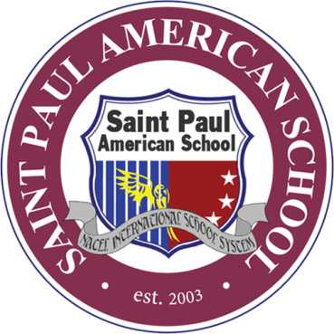
Saint Paul American School

Clark Center 4, Berthaphil, Jose Abad Santos Avenue,
Clark Freeport Zone, Pampanga, Philippines (023
www.stpaulclark.com / admissions@stpaulclark.com
(045).499.1373 / +63.962.066.9170

Welcome to Saint Paul American School (SPAS). We offer K-12 course, Advanced Placement program and full American curriculum. Our foreign and local teachers are certified. Currently, we have students from the US, the UK, Canada, Australia, China, Myanmar, Japan, India, Costa Rica, Russia, Mongolia, Vietnam, Taiwan, KSA, Korea and the Philippines.

SPAS is located inside the Clark Freeport Zone. This zone is self-contained with its own international airport just 5 minutes away. We boast more than 14 classrooms for elementary and more than 20 for middle high school as well as our spacious gymnasium, playground and running track. Each department has its own computer laboratory and library. Our in-house cafeteria offers international food every day and can sit more than 50 students.

REQUIREMENTS FOR ENROLLMENT:

- Official Transcript of Records (Form 137)*
- Report Card (Form 138)*
- 6 pieces 2”x2” photo with white background, without eye glasses
- Birth certificate (for Philippine citizens only)
- Scanned copy of passport (for non-Philippine citizens only)
- Scanned VISA copy of both Parent and Student applicant

*Must be APOSTILLED if previous school from abroad

STEPS FOR ADMISSIONS:
- Submit all requirements.
- Submit filled out student information form.
- Submit the medical information form signed by preferred Physician.
- Submit the signed school-parent agreement form (for dormitory students only).
- Submit the signed refund policy form.
- Pay tuition and fees (as discussed and agreed during your inquiry).

